**KTS GOVERNMENT DEGREE COLLEGE ,RAYADURG,ANANTAPUR (DT)**

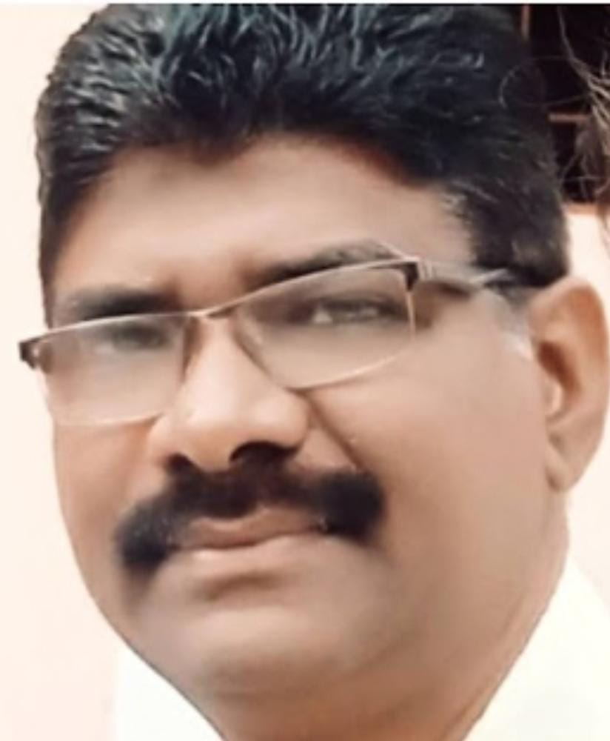

|  |  |
| --- | --- |
| **Name of the faculty member** | **Dr. K.LAKSHMINARAYANA** |
| **Designation** | **Lecturer in Telugu** |
| **Qualification** | **M.A., M.Phil., Ph.D., B.Ed.,APSET** |
| **Mobile** | **9885738679** |
| **E-mail** | **madhava.mouli@gmail.com** |
| **Date of Birth** | **01-07-1969** |
| **Caste** | **BC-B (Kuruba)** |
| **College** | **GDC(M), UG & PG College, Ananthapuramu** |

**Academic Record**

|  |  |  |  |  |
| --- | --- | --- | --- | --- |
| **Course** | **Year** | **% Marks** | **Class/Grade** | **University** |
| M.A., | 1994 | 68.80% | I Class | S.K.U. |
| M.Phil., | 1997 | 66.50% | I Class | S.K.U. |
| Ph.D., | 2007 | 66.50% | I Class | S.K.U. |
| B.Ed., | 1999 | 62.00% | I Class | S.V.U. |

**Title of the Thesis/Dissertation**

**M.Phil.,**

Viswanatha Visweswara Satakama, Oka Pariseelana

**Ph.D.,**

Viswanatha Visweswara Madyakkara Satakala Pariseelana

Gold Medal Awarded

Date of Appointment as DL : 05-11-2010

State Level Eligibility Test 27-07-2012, (Osmania University, Hyderabad)

**Details of Paper Presentation in academic Conferences/Seminar**

|  |  |  |  |  |
| --- | --- | --- | --- | --- |
| **S. No.** | **Title of the paper presented** | **Organized by** | **International/ National/ State/ University Level** | **Period** |
| 1. | Puttaparthy Sahityam – Bhagavath Bhakthi | GDC(M) Ananthapuramu | National | 23, July 2011. |
| 2. | Bhatruhari Subhashithalu – Manavatha Viluvalu | SSBN Degree College, Ananthapuramu | National | 28, 29 April, 2012 |
| 3. | Abolition Child Labour in Agriculture Sector | Silver Jubilee College, Kurnool | National | 29, 30 August, 2012 |
| 4 | Gurajada Muthyala Saralu – Adhuniktha | SKU Telugu Saka, Ananthapuramu | National | 20, 21, September 2012 |
| 5. | Vaidhya Sastram – Neethi | GDC(M) Ananthapuramu | National | 23, 24, 25 November, 2012 |
| 6. | Environmental Governance an Overseas | GDC, Kalyandurg | National | 22, 23 February, 2013 |
| 7. | Recent Trends in Indian English Fiction | GDC, Porumamilla | National | 27, 28 February, 2013 |
| 8. | Prasaramadhymalu – Upadi Kosam Melakuvalu | GDC, Nizamabad | National | 5 March, 2013 |
| 9. | Srikala Hasthiswara Sathakam – Bhakthi Vaisistam | GDC, Kalahasthi | National | 6,7 March, 2013 |
| 10. | The Role of Watershed in Rural Development | GDC, Armoor | National | 7,8, Dec. 2013 |
| 11. | Prapachikarnamalo Sastra Sankethika Padajalam – Telugu Samanarthakala Uthpathi | Osmani College, Kurnool | International Seminar | 25, 26, February 2014 |
| 12. | Pala Venkatasubbaiah Kavitvam – Samajikatha | SKU Telugu Saka, Ananthapuramu | National | 26, 27, March, 2014 |
| 13. | Conserving Bio-diversity in the face of climate change | GDC(M) Ananthapuramu | National | 27, 28, June, 2014 |
| 14. | Resolving Intra Personal Crises | GDC, Kalyandurg | National | 9, 10 July, 2014 |
| 15. | Aahara Bhadratha Oka Pariseelana | GDC(W) Ananthapuramu | National | 20, 21 August, 2014 |
| 16. | Rayalakalam Nati Prajala Aahara Aharyamulu | Govt. of Andhra Pradesh | National | 28 August, 2014 |
| 17. | An Insurance for our future | GDC(M) Kurnool | National | 12 December, 2014 |
| 18. | Ravuri Bhardwaja Pakudurallu – Cini Vasthavalu | GDC(W) Kurnool | National | 6, 7 January, 2015 |
| 19 | Naithkavidya Thone Desabivruddi | GDC(W) Ananthapuramu | National | 10 March, 2015 |
| 20. | Telugu Sakalalo Manavatha Viluvalu | GDC, Kadapa | National | 18,19 March, 2015 |
| 21. | Ethics in Education | Govt. College, Ananthapuramu | National | 2nd May, 2015 |
| 22. | Human Rights and Public Libraries | Govt. College, Ananthapuramu | National | 30th November, 2015 |
| 23. | Child Trafficking a Grave Violation of Child Rights | Govt. College, Ananthapuramu | International | 10-12, August, 2016 |
| 24. | Vidwan Viswam Okanadu Kavyamlo Pranthiya Asthityvam | Govt. Degree College, Kalyandurg | National | 2,3 February, 2017 |
| 25. | Sarvepalle Education Philosophy | Govt. College, Ananthapuramu | National |  |
| 26. | Visveswara Sathaka Vaisistam | S.R.R. & C.V.R. Govt. Degree College, Vijayawada, A.P. | National | 7, 8 September, 2017 |
| 27. | Human impact on bio-diversity strategies for future conservation | Department of Zoology, GDC, Anantapuramu | National | 5,6 October 2017 |
| 28. | Jashva Sahityam lo Saamagika Chaitanyam | Govt. College(A) Ananthapuramu | National | 8,9 February 2018 |
| 29. | Biodiversity and Conservation Strategies | Govt. College(A) Ananthapuramu | National | February 28 March, 1, 2018 |
| 30. | Mahabharatam Manavatha Veluvalu | Sri Saibaba National Degree College | National | 14, 15 March, 2018 |
| 31. | Neethi Satakalu Sanga Sanskarana | SIR C.R. Reddy College (Aided and Autonomous) Eluru | National | 14, 15 December 2018 |
| 32. | Bharathiya Bakthi Sahityam Ramuni Patra | Sri Venkateswara Oriental Degree and PG College, TTD, Tirupati | National | 14, 15 February, 2019 |
| 33. | Mahabharatham lo Manaveeya Viluvalu | Govt. College(A) Ananthapuramu | National | 15, 16 February, 2019 |
| 34. | Role of Digital Library in Modern Education | Govt. College(A) Ananthapuramu | National | 4,5, January 2020 |
| 35. | Environmental Protection | Department of Chemistry, Govt. College (A), Ananthapuramu | National | 6,7 February, 2020 |
| 36. | Women in Politics | Women Empowerment Cell Govt. College (A), Ananthapuramu | National | 5,6 March, 2020 |
| 37. | Jateeyhodhamam lo Telugu Sahityam | KVR Govt. College for Women | National | 26, 27 February, 2020 |
| 38. | Problems of Sustainable Agriculture Development in India | Department of Economics Girraj Govt. College (A) Nizamabad | National | 13,14 March, 2020 |
| 39. | Jatiyodyama Kavitavam | Govt. Women College (A) Guntur | International Webinar | Aug 10211-2022 |
| 40. | Boya Bhemanna Cyeyalu Jateeya Balupu | Sri Sri Kalavedika Mahabodhi Sahitya Vedika | National |  |

**ISBN/ISSN Articles**

|  |  |  |  |  |  |
| --- | --- | --- | --- | --- | --- |
| **Sl. No.** | **Title of the Books** | **Name of the Paper Presented** | **Month/ Year** | **ISBN/ISSN No.** | **Page No.** |
| 1. | Dr. Ravoori Bharadvaja (Saahitya Samaalochana) | Ravoori Bharadvaja Pakudurallu Cenevastavalu | March 2015 | **ISBN**  978-93-85101-04-5 | 74 |
| 2. | Evaluation of inclusive growth strategies in Rural Development | Progress of inclusive growth through Mgnregs in Anantapuramu District, A.P. | April 2015 | **ISBN**  978-93-82163-35-0 | 331 |
| 3. | Protection & Promotion of human rights Role of Civic Society | Human Rights and Public Libraries | Nov. 2015 | **ISBN**  978-93-5-5171-062-2 | 59 |
| 4. | Human Trafficking in Asian Countries Dynamics and Dimensions | Child Trafficking – A Grave Violation of Child’s Right | Aug. 2016 | **ISBN**  978-93-1071-100-1 | 136 |
| 5. | International Journal of Multi Disciplinary Advanced Research Trends | Telugu Bhasha Pai Prapanchikarana Prabhavam | Nov. 2016 Volume III issue 2(a) | **ISSN**  2349-7408 | 196 |
| 6. | Regional Secretary, Kendra Sahitya Academy, Bangalore | Symposium on Birth Centenary of Vidyavan Viswam Okanadu Pariseelana | Aug 2016 | SAS.86A/BCS-VV/2016/4630 |  |
| 7. | International Journal of Multi Disciplinary Advanced Research Trends | Kaitha Naa Dayita Pattabhi | July 2019 Volume VI Issue 2(i) | ISSN 2349-7408 | 100 |
| 8. | Bhava Veena Special Edition | Jateeya Udyamamlo Telugu Sahityam | Feb 2020 Volume 17 Issue 02 | ISSN 2456-4702 | 358 |
| 9. | Bhava Veena Monthly | Jaati Garvincha Dagga Kavi Thummula | Jan 2021 Volume 18 Issue 1 | ISSN 2456-4702 | 27 |
| 10. | Bhaa Veena Special Edition. | Jateeyodyamamlo Telugu Kavula Patra | Aug. 2022 Volume 19 Issue 8 | ISSN 2456-4702 | 75 |
| 11 | POSITIVE TALK | Multidisciplinary Peer Reviewed Journal  MULTILINGUAL INATERNATIONAL CONFERENCE  “ Pothana Bagavatham Bakti Tatvam” | Sep 25&26  2023 | ISSN 2582-6247 | 187 |
| 12 | EDUCATIONAL SOCIETY | UGC CARE LISTED PERIODICAL  “Si.Na.Re patallo Gandhi Prastavana” | OCT &DEC 2023 VOL -47 Issue One | ISSN 2278-6864 | 151 |
| 13 | ER PUBLICATIONS | INTERNATIONAL JOURNAL OF ENHANCED RESEARCH IN EDUCATIONAL DEVELOPMENT  Vemana Padyalu Samajika chaitanya Geetalu” | SEP& OCT 2023 | ISSN 2320-8708  UGC JOURNAL NO 2799 Impact factor 7.326 | 239 |

**Details of Consultancy Work**

|  |  |  |  |
| --- | --- | --- | --- |
| **Sl. No.** | **Name of the Institution** | **Consultancy Work** | **Date** |
| 1. | Vijayanagara Sri Krishnadevaraya University, Bellary, Karnataka State | B.A.,B.Com., B.Sc., B.C.A., General Telugu Paper Setting | 15-10-2014 |
| 2. | The Director, Directorate of Distance Education, SK University, Anantapuramu | B.A., Advance Telugu (**Old** Regulations) | 29-01-2015 |
| 3. | The Director, Directorate of Distance Education, SK University, Anantapuramu | B.A., Advance Telugu (**New** Regulations) | 29-01-2015 |
| 4. | Vikrama Simhapuri University, Nellore | B.A., Special Telugu Paper Code-111021 | 14-10-2015 |
| 5. | Vijayanagara Sri Krishnadevaraya University, Bellary, Karnataka State | B.A.,B.Com., B.Sc., BBM., B.Sc., (Bio-Tech) 1st and 3rd Semesters General Telugu Paper Setting | 16-10-2015 |
| 6. | Vijayanagara Sri Krishnadevaraya University, Bellary, Karnataka State | B.A.,B.Com., B.Sc., BBM., 2nd and 4th Semesters General Telugu Paper Setting | 07-04-2016 |
| 7. | Vikrama Simhapuri University, Nellore | B.A., Advanced Telugu Paper Code-11021 | 23-08-2016 |
| 8. | The Controller Examinations, KVR Govt. College for Women (A), Kurnool | B.A., Advanced Telugu | 21-09-2016 |
| 9. | Vikrama Simhapuri University, Nellore | B.A., Special Telugu Paper Code-1107SPT16 | 25-09-2016 |
| 10. | Vijayanagara Sri Krishnadevaraya University, Bellary, Karnataka State | B.A.,B.Com., B.Sc., BBM., B.Sc., (Bio-Tech) 1st and 3rd Semesters General Telugu Paper Setting | 07-10-2016 |
| 11. | Silver Jubilee Govt. College (A), Kurnool | Valued 132 General Telugu Answer Scripts | 29-11-2016 |
| 12. | Vijayanagara Sri Krishnadevaraya University, Bellary, Karnataka State | B.A.,B.Com., B.Sc., BBM., B.Sc., (Bio-Tech) 1st and 3rd Semesters General Telugu Paper Setting | 12-10-2017 |
| 13 | Yogi Vemana University, Kadapa. | 1st B.A., Special Telugu Paper Setting. | October 2017. |
| 14 | Vijayanagara Sri Krishnadevaraya University, Bellary, Karnataka State | B.A.,B.Com., B.Sc., B.C.A., General Telugu Paper Setting | 22-02-2024 |

**1. Details of refresher courses attended**

|  |  |  |  |
| --- | --- | --- | --- |
| **S.No.** | **Item** | **Organized by** | **Period** |
| 1 | Strategies for Research Oriented Teaching | JNTU, Hyderabad. | 05-06-2017 to 24-06-2017 |
| 2. | Health Management (Inter Disciplinary Course) | Sri Venkateswara University, Tirupati. | 12-11-2018 to 01-12-2018 |
| 3. | Refresher Course in Telugu | Osmani University, Hyderabad. | 18-11-2019 to 30-11-2019 |

**2. Details of orientation courses attended**

|  |  |  |  |
| --- | --- | --- | --- |
| **S.No.** | **Item** | **Organized by** | **Period** |
| 1. | Orientation | Osmania University, Hyderabad | 28-8-2012 to 31-10-2012 |

**3. Details of Faculty Development Programme(F.D.P.)**

|  |  |  |  |
| --- | --- | --- | --- |
| **S. No.** | **Item** | **Organized by** | **Period** |
| 1. | Telugu Pathya Bhodana Nipunyalu – Melakuvalu (online) | Department of Telugu, Adikavi Nannaya University, Rajamahendravaram | 18-06-2018 to 01-07-2020 |
| 2. | ICT Tools for Effective teaching learning (online) | Swami Ramananda Theerth Marathwada University, Nanded | 11-05-2020 to 16-05-2020 |
| 3. | Emerging Trends of Pedagogy in Language, Literature and Social Science (online) | Ramanujan College of University of Delhi and Shyam Prasad Mukharji College for Women University of Delhi | 13-07-2020 to 19-07-2020 |
| 4. | Time Series and Panel Data Analysis (online) | Ramanjuna College University of Delhi and Indian Accounting Association NCR Chapter. | 20-07-2020 to 26-07-2020 |
| 5. | 115 Online Short Term Course on E-Content Development | UGC Human Resource Development Centre, Gujarat University, Ahmadabad. | 06-08-2020 to 12-08-2020 |

**3(A). Details of training taken:**

|  |  |  |  |
| --- | --- | --- | --- |
| **S.No** | **Title of the course attended** | **Organized by** | **Date & period** |
| 1 | 3 Days Introduction Training Programme | Commissioner of Collegiate Education, Govt. of Andhra Pradesh | 14/11/2011 to 16/11/2011 |
| 2 | S.K.U. D.D.E. Orientation Programme for Course Writers/Transforming Course material into SLM | Distance Education Bureau, UGC, SK University, Ananthapuramu | 28/3/2014 |
| 3 | 3 Days Training Programme on “A Foundation Course in human values and Professional Ethics” | GDC(M) Ananthapuramu | 25/9/2014 to 27/9/2014 |
| 4 | Capacity Building Training Program | UGC MALAVYA MISSION TEACHER TRAING CENTER UNIVERSITY OF HYDERBAD | 16-04-2024 to 27-04-2024 |

1. **Invited lectures or presentations for conferences/symposia:**

|  |  |  |  |  |
| --- | --- | --- | --- | --- |
| **S.No** | **Name of the institution** | **Name of the Topic** | **International/ National/ State/University level** | **Date & Period** |
|  | -Nil- | -Nil- | -Nil- | -Nil- |

**Any other information**

|  |  |
| --- | --- |
| Coordinator for College Level Cultural Activities | 2011-2013 |
| Member for Andhra Saraswatha Sangam | 2013-2015 |
| Time Table Committee Member | 2012-2013 |
| Convener for College Level Cultural activities | 2013-2023 |
| District Level Cultural Co-Ordinator | 2013-2017 |
| Deputy Warden, Student Managed Hostel, Govt. College(A), Anantapuramu | 2013-2018 |
| College Building Committee Member | 2016-2017 |
| College Drama Hall Committee Member | 2016-2017 |
| Hostel Committee Member | 2018 to 2023 |
| Cultural committee convener ,KTS Govt.Degree College, Rayadurg | 2023 Sep to till Date |

**Record of Extension Work**

|  |  |
| --- | --- |
| 13-01-2014 | Prizes were distributed to the winners in Yuvajanotsavam-2014 |
| 13-01-2014 | Appreciating the students who won State Level IIIrd Prize in Spot Painting in 2013 Yuvatarangam |
| 22-02-2014 | Conducted ‘Matrubhasha – Dinotsvam’ by Mother Tongue Protection Committee, Arts College (Telugu Language Protection Committee) |
| 26-09-2014 | Giving speech in the Arts College on the occasion of the birth anniversary of Modern poet Gurajada Apparao |
| 04-11-2014 | Participating in the falicitation to the S.K.U.. Registrar Prof. Ramana |
| 29-08-2015 | Speech given on the occasion of the Mother Tongue Day (Matrubhasha Dinotsavam) conducted by Eenadu Newspaper |
| 17-09-2015 | Acted as a coordinator for the cultural programs conducted by District Youth Services in the Arts College |
| 24-01-2016 | Addressing the students on the occasion of the 120th Birth Celebrations of modern poet Jashuva conducted by the Department of Telugu |
| 04-03-2016 | Inviting Padmasri Awardee Sri Kolakaluri Inak to the college and facilitating him by the Department of Telugu |
| 17-03-2016 | Encouraging and making the students to participate in Yuvatarangam 2015 by giving practice in many fields. |
| 03-05-2016 | Presenting pries to the NET, SLET qualified who has been given free coaching for the Net, SLET Exams by the Department of Telugu |
| 30-07-2016 | On the occasion of Centenary Celebrations of Vidvan Viswam the Kendriya Sahitya Academy organized a meeting on this occasion presented a paper on Vidwan Viswam OKANADU KAVYAM at K.S.N. Govt. College, Anantapur. |
| 29-08-2016 | Giving suggestions to protect Telugu Language Identity, conducted by Eenadu Newspaper on the occasion of ‘Telugu Bhasha Dinotsavam’ |
| 30-08-2016 | Participating in the procession along with the students on the occasion of Telugu ‘Bhasha Dinotsavam’ and Garlanding the Mother Goddess Telugu |
| 29-03-2017 | Participating in the awareness Programme conducted by EENADU Newspaper on the occasion of ‘Ugadi Sambaralu’ by Prof. Shakala Raghunatha Sarma. |
| 20 -11 -2020 | Extension lecture on Special Telugu 3rd Year students |